| **Hello everyone,**  **I hope you are managing Lockdown part 3 whilst very much dealing with winter pressures.**  **Sadly more of us have been touched personally by this pandemic.**  **New Year there is some brightness on the horizon.The advent of the COVID-19 vaccination programme. Although it seemed like a tall order and multiple changes from NHS England we have made a great start to this vital programme. I am extremely proud of the collaborative approach led by East Park. More work is needed to ensure all of our patients have the opportunity to make an informed decision. Thank you for being the trusted voices needed to encourage hesitant patients.**  **The newsletter is a little longer than usual, find enclosed information regarding lots of new staff that have joined us since October.  We have a virtual meeting with the new starters and our other ARRS staff planned for 9th March. They are negotiating the difficult task of building relationships with social distancing and virtual meetings.**  **I hope you stay safe and well and as always, feel free to contact myself or Dr Paul regarding the PCN .**  **Dr Nadia Anderson**  **Dr Nadia Anderson** | **New Starters**  **Safina Akhtar**  joined us on 7th December as our Pharmacist Technician. After completing her induction and training, she carried out safety checks for Methylcelluose and Methotrexate for all our PCN patients and this piece of work is now complete. She is currently looking at ensuring all patients on steroid medication carry “steroid cards” in case of an emergency to ensure they are treated accordingly. She continues to support the Covid Vaccination hub.  C:\Users\Remote\Pictures\Safina.jpg  **Gill Lambert** joined us on 13th October as Practice Manager at The Roundhay Road Surgery.  She previously worked as a Business Manager at LTHT and came out of early retirement to join the PCN. She continues to help out in the East Park vaccine hub and looks forward to meeting more of you, in person, in the future.  C:\Users\Remote\Pictures\Gill Lambert (2).jpg  **Gill Lambert** joined us on 13th October as Practice Manager at The Roundhay Road Surgery.  She previously worked as a Business Manager at LTHT and came out of early retirement to join the PCN. She has recently been helping out in the East Park vaccine hub and looks forward to meeting more of you, in person, in the future.  F | **Contents**   1. **Message from CDs** 2. **New Starters/leavers** 3. **PCN workforce** 4. **Patient Ambassadors** 5. **Community Cancer Support Service** 6. **Physios update** 7. **Extended Access Services** 8. **Apprentice Project Worker** 9. **Mental Health Lead** 10. **Leeds Mental Wellbeing Service** 11. **Pharmacists PCN Priorities** 12. **Care Homes** 13. **Respiratory Nurse** 14. **Integrated Nurse** 15. **Other Services** | **Recruitment**  Currently no PCN vacancies  .  BHR PCN  March 2021  ***Our principles, keep staff safe, support each other and protect patients*** | **Leavers**  Michael Hart has left NLMP and has joined Leeds Student Medical Practice as Operations Manager. He will be missed but we wish him all the best for the future.  Florence Applegate has left her role as Practice Coordintor at Shakespeare Medical Practice who are currently recruiting a replacement. |  |
| --- | --- | --- | --- | --- | --- |

| **Patient Ambassadors**  **Sam Hirst**  joined us on 7th December initially to support Bellbrooke’s winter resilience project. He has been shadowing Sharon and Shaun to learn the PA role. He has been supporting the Covid Vaccination programme by booking in patients. He has also been shadowing Miranda (MH Lead) and learning aspects of her role and how to facilitate the working groups she has set up. He has recently joined our expanding team of Patient Ambassadors.    Care homes  Social deprivation  Integrated nurse  Mental health lead  Pas  Respiartory clinics  Physios  LMWS  Integrated woundcare    cid:image009.png@01D64E16.A01A1800C:\Users\Remote\Pictures\Sarah (2).jpg  **Sarah Wadsworth**  **Aman Keflay**  **Sarah Wadsworth** **and Aman** **Keflay** both joined us on 11th January as Patient Ambassadors. They shadowed Shaun and Sharon and have completed their mandatory training induction. Objectives and outcomes are currently being worked on so more about what their new role will look like will be cascaded in due course.    Care homes  Social deprivation  Integrated nurse  Mental health lead  Pas  Respiartory clinics  Physios  LMWS  Integrated woundcare | Helen McEwan and Sohail Asmat both joined us on 25th January They have been shadowing Shaun and Sharon and are now picking up referrals and speaking with patients, as well as working on team projects. Sanya Zubair has just joined the PA team on 22nd February and is working her way through the induction.    C:\Users\Remote\Pictures\Sohail.jpg  **Sanya Zubair**  **Helen McEwan**  **Sohail Asmat**  Fahima Matin will re-join the team upon her return from Maternity leave in June. The team of 9 PAs will together develop a team approach to delivery and ensure this is undertaken on a population health management basis rather than just allocation of individuals/time to specific practices.  The team will be managed by Sophie Peel from Hamara.  C:\Users\Remote\Pictures\Sophie Peel.jpg  **Sophie Peel** | **Care Homes Team**  Anna Willis joined us in December as a Physician  Associate in the Care Homes Team at East Park.  She has been taking her own clinics, helping diagnose  and manage patients with undifferentiated histories.  She has also been involved with the care of patients at  the community intermediate care beds. She continues  to administer the COVID 19 vaccine in the hub at E/P    Tracy Booth joined us on 4th January as our Care Homes Coordinator and is based at East Park. She is the main point of contact for the care homes; dealing with all queries and requests for meds, results and visits etc. East Park have taken over responsibility and care of our PCN’s CH patients. The role and the team are very new so it will take time for processes to be embedded.  As part of her induction, she has spent time helping out at the Covid Vaccination hub.  C:\Users\Remote\Pictures\Tracy (2).jpg |
| --- | --- | --- |

**Extended Access**

**First Contact Physiotherapists**

**Community Cancer Support Service**

**Extended Access Services**

**held at Conway Medical Centre**

* A Paediatric clinic has been running for a while now, *every weekday* between 4 pm and 6 pm.
* 2 HCA clinics started on 6th February and will be held *every Saturday* between 10 am and 4 pm.
* A Practice Nurse smear session is running *every Saturda*y between 10 am and 4 pm.
* A GP Sexual Health Clinic commenced 30 January and will be held *every Saturday* between 10 am and 4 pm. The process to be followed when booking into the LARC clinic (for coils and implants) has previously been circulated to all Practice Managers.

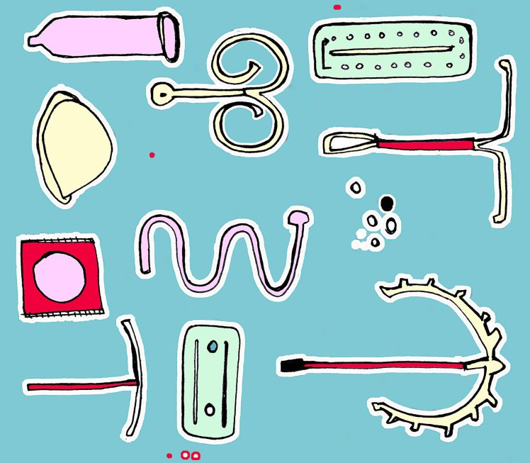

Practices have not been allocated a set number of appointments for each of the above clinics; they are all on a first come first served basis. The rotas can be found on the Extended Access hub.

Should you have any queries regarding these services please contact:

**Tracy Lindsay**

Operational Team Leader

**Tel:** or 0113 887 3899 M: 07857603709

**Email:** [tlindsay2@nhs.net](mailto:sam.cunningham@nhs.net) | [opsteam.lwpcn@nhs.net](mailto:opsteam.lwpcn@nhs.net)

Leeds GP Confederation | Park Edge Practice | Leeds | LS14 1HX

The Community Cancer Support Service is now live in 7 PCNs across Leeds, including our neighbouring PCN, Chapeltown.

Since go live on 7 September, the team has been working proactively with practices to identify suitable patients and invite them to meet with the service. So far 9 patients from BHR PCN have had an appointment.

The service will improve cancer patient’s access to local support services and help them to lead as full and active life as possible. In addition to offering Cancer Care Reviews within 6 months of a diagnosis, the team will use a holistic approach to supportive self-management through emphasising patients’ concerns and using the “what matters to me” approach to personalised patient care.

The team offer a patient clinic at Chapeltown HC on Monday afternoons in addition to home visits and virtual/phone appointments. Senior Nurse Karen McKernan ([karen.mckernan1@nhs.net](mailto:karen.mckernan1@nhs.net)) and Care Navigator Rabina Majid ([rabina.majid@nhs.net](mailto:rabina.majid@nhs.net)) are now in post and supporting patients in this area, in addition to the Clinical Team Manager Gemma Brooksbank ([gemma.brooksbank@nhs.net](mailto:gemma.brooksbank@nhs.net)).

For more information or to refer a patient please contact [community.cancersupport@nhs.net](mailto:community.cancersupport@nhs.net). The CCSS referral form can be found on your SystmOne units.

**Karen**

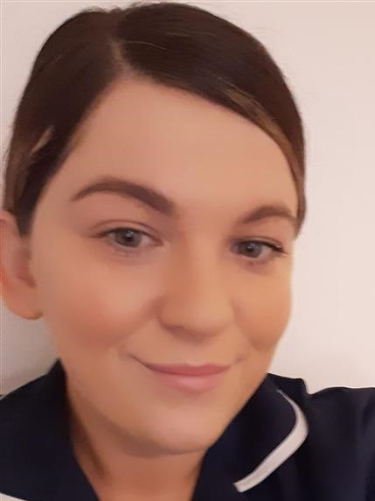



The Physio team have now returned to practice and are delivering services from East Park, Bellbrooke and Conway. Most of you will already know Angie and Sarah, Ben Foxcroft has also now joined the team.

**Ben**

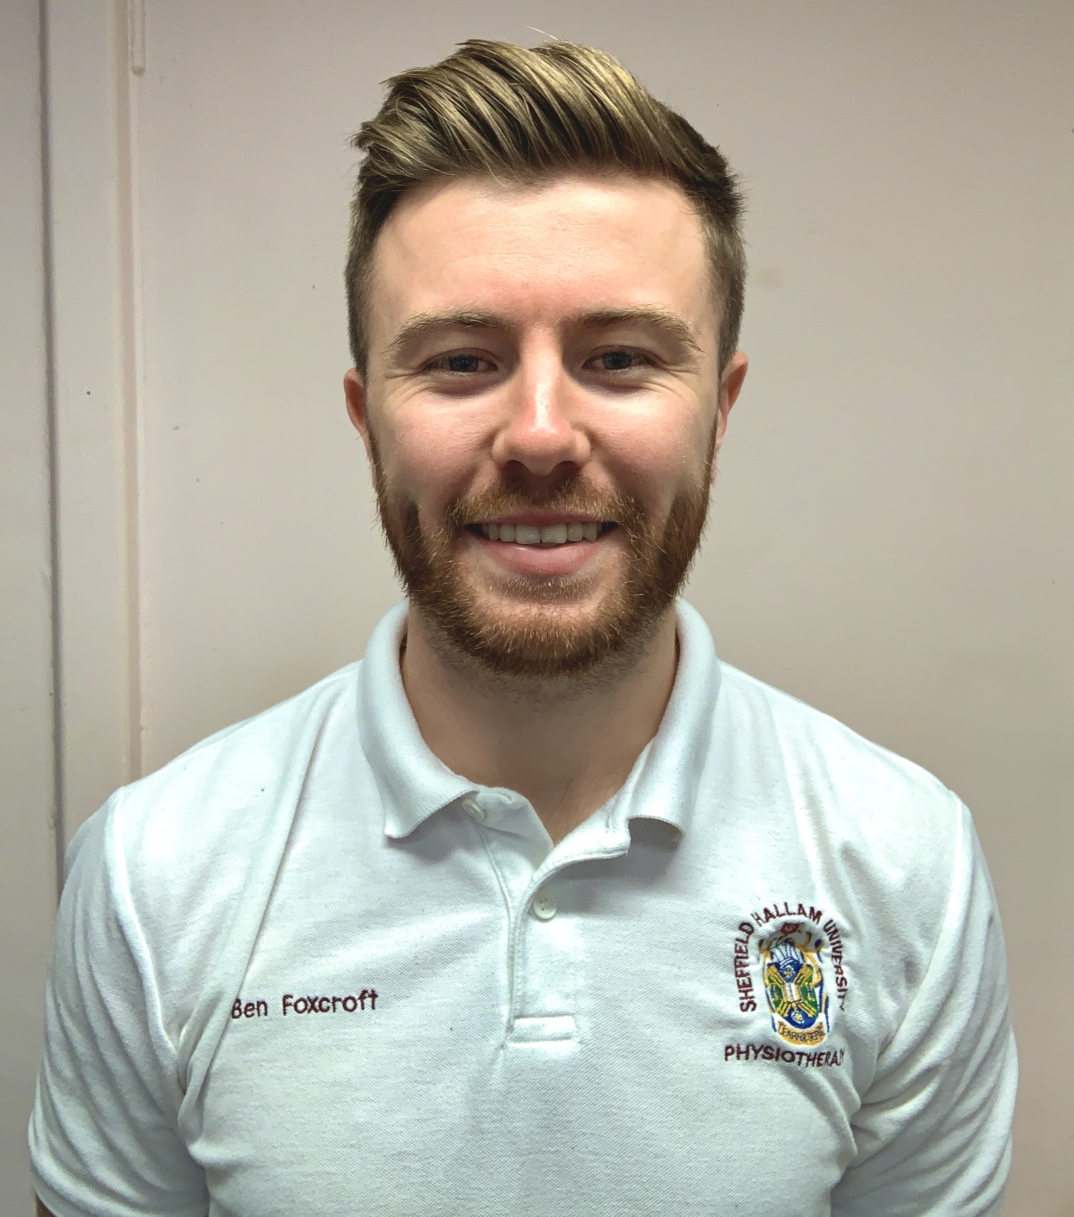

All slots are assessment and treatment. Most treatments are being carried out virtually (telephone or video) as much as possible with the ability to bring patients in if deemed appropriate and necessary in the current climate.

*Practices should book appointments into the rotas on the hub in the usual manner pre Covid.*

***.***

Aamina and Sonia have both settled in well over these last few months. Aamina started her Maternity Leave at the end of February and is expected to return after 6 months. Safina our new Pharmacist Technician has now completed her induction.

**Abdha Parveen** started at the end of February as a Clinical Pharmacist for the care homes team at East Park. She has just completed her week long induction and will work with Dr Jo Cummings to draw up a plan and discuss the team’s priorities.



The pharmacists have clear training plans and GP mentor support and are working alongside the team delivering Covid vaccines. They are delivering ad hoc projects for us as identified by clinicians in the PCN.

Undertaken so far:

* Reviewed amber drug processes across all PCN practices and put in place more robust systems to ensure safe prescribing of amber drugs
* Updated a PCN-wide repeat prescribing policy which also includes the amber drug policy – this has been sent to all for comment before being implemented.
* Supported practices with clinical documents and queries where needed
* Supported with the Covid vaccination rollout
* Care home support - clinical support
* Methotrexate safety audit - day of the week taken
* Methylcellulose discontinuation alert

Going forward:

* Emergency steroid cards - reviewing patients and sending out alert cards
* Structured medication reviews
* DES medicines safety work and clinical review
* Care home support - supporting with medication reconciliations, reviews and clinical queries
* Ongoing Covid vaccination support
* Phyllocontin discontinuation alert
* General clinical queries

**Leeds Mental Wellbeing Service**

Kirsty has been in post 6 months but restrictions caused by Covid have restricted success to date. She has however managed to work a little with Bellbrooke Surgery and the Patient Ambassadors to facilitate the following working groups:

* **Walking Group**- for patients who would benefit from low impact physical activity and a chance to socialise with the community

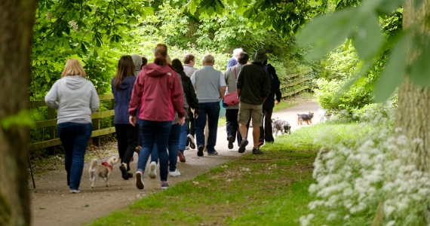

* **Intercultural Groups**: focusing on Sleep Hygiene and build on ideas on how we can support each other to sleep well through stressful times- particularly when considering issues with refugees and asylum seekers. Also working in partnership with Mentally Healthy Leeds to identify patients to become Community Health Champions for men’s health, particularly exploring low mood.
* **West Yorkshire Playhouse and Public Health**- young people in the Harehills area, through partners, will be working on a collaborative project to explore health inequalities in young people through creative workshops.

In our last newsletter, Kirsty described a project she was leading on called “Developing You”. The first programme of this education project supporting people to return to work has been completed; an ongoing communication will remain for next couple of months with further sessions planned virtually (if needs be) within the next month or so – or face to face from April/May onwards. As a result, it has been possible to support patients in finding some form of full time and part time employment; 4 being from Harehills.

She is hoping to re-visit New Parents group, which will focus on first time parents in the pandemic and Carer’s Group (for carer’s associated with local practices).

**Apprentice Project Worker (Kirsty)**

**Mental Health Lead (Miranda)**

**Clinical Pharmacists**

The waiting list for support group sessions is now open again, so please send patients with identified mental health needs, via task on Emis and via email for S1.

From mid- January, one “Introduction to Group Work” session per week will run, to bring new patients through into the HEROES programme. Please make sure patients give their consent before referring. Alternatively print out attached programme for them to take away and self-refer.

Click on link for more information.



Hoping to start generalised online support group sessions shortly and will keep you posted.

Weekly face to face women’s group up and running from mid-January. This will run every Wednesday 10-12 from now on. If demand is there, another group can be to set up.

Miranda has recently reduced her working hours but will continue to supervise delivery of groups but use other staff (Patient Ambassadors) and/or patients to facilitate sessions

See link below to a paper giving detailed informing on the following:



* BHR Referral Data from Jan -Dec 2020
* A reminder to referrers
* Staffing Update: new starters and leavers
* Psychological Wellbeing & Diabetes – new online course

[online-group-classes/psychological-wellbeing-diabetes/](https://www.leedscommunityhealthcare.nhs.uk/our-services-a-z/leeds-mental-wellbeing-service/online-group-classes/psychological-wellbeing-diabetes/)

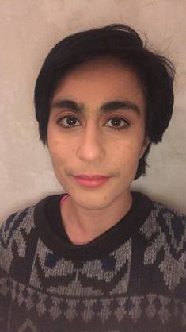

**Amareen Afzal**

**Child Health Hub** – currently analysing information on referrals not accepted so we can do some work on improving acceptance rates; delivery of community service currently ‘on hold’ due to Covid.

**Childhood Immunisations** – continues in practice but otherwise delivery of community service currently ‘on hold’ due to Covid.

**Deprivation Project –** we remain committed to having a clear and defined plan for developing how we manage deprivation and health inequalities including digital options and will refresh and re-start this project shortly.

**HATCH –** our frailty project is partly delayed/changed due to Covid and recruitment issues – at this stage managed through the LCP and has no impact on PCNs – need to look at why this is and how we can involve PCNs more with this work stream and the LCP in general moving forward.

We have recruited into our 2nd post for care coordinator held jointly with Chapeltown PCN. **Amareen Afzal** will be based with our 3rd sector colleagues Feel Good Factor. Amareen will be working with patients with diabetes and living with moderate frailty in the most deprived postcodes.

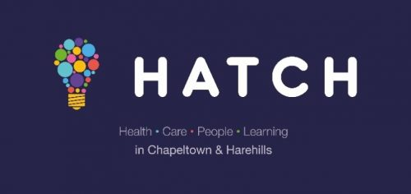

**Integrated Woundcare Clinic** has had to be discontinued due to shortage of nurses.

There is a specific plan in place to complete transfer of care homes internally and externally and then allow East Park to deliver and develop the service.

To support delivery, a Care Homes Team has been recruited consisting of a care Co-ordinator, Physician Associate and Pharmacist. The team is very new and needs time to deliver and develop their model.

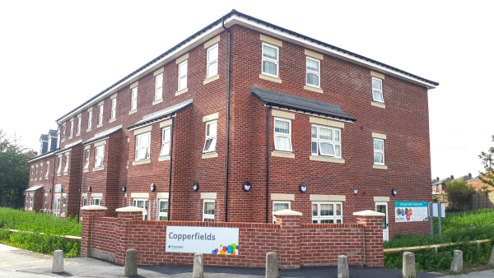

**Respiratory Nurse Lead (Mel)**

Mel has been virtually contacting our high risk

Respiratory patients.

Mel and Lisa, have vaccinated all our housebound patients with the flu vaccine.

She will continue to support practices with their QOF/QIS targets albeit they are not a priority**.**

Lisa and Mel vaccinated all our housebound patients with the flu vaccine.

Lisa was asked to be part of the core team headed by

Jo Cummings to give the first Pfizer vaccines at East Park

for the over 80s and NHS staff.

Their model proved to work well and other health care

professionals were welcomed to train and observe, to enable a city wide team to roll out these vital vaccinations. This ensured residents of our care homes as well as their staff were able to receive the vaccination after Christmas.

Lisa has also been assisting Mel to call the highest risk patients.

She has enrolled on the Diabetes management course which starts in February and completes in August. There is a high prevalence of Diabetic patients within our PCN so we will look at how Lisa’s role can develop to improve the lives of this cohort.

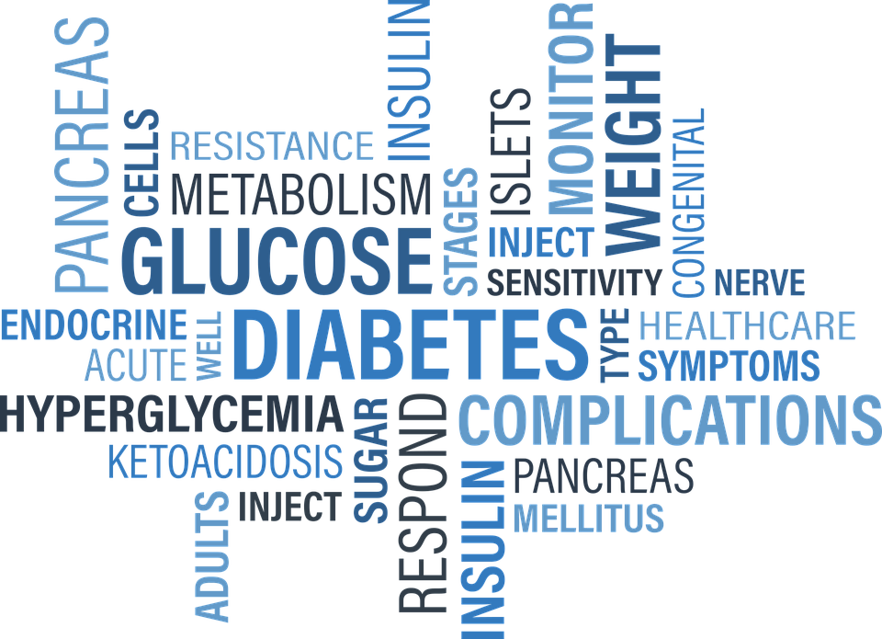

She has continued to link in with the neighbourhood teams and hopefully this will facilitate a more joined up way of working between both primary care and the community team to prevent duplication of work and resources.

Also noted the restrictions on developing this role due to Covid and how this may have restricted the variety of options open to us so far.

**Care Homes**

**Integrated Nurse Project (Lisa)**

**Other Services**